Feast of All the Faithful Departed
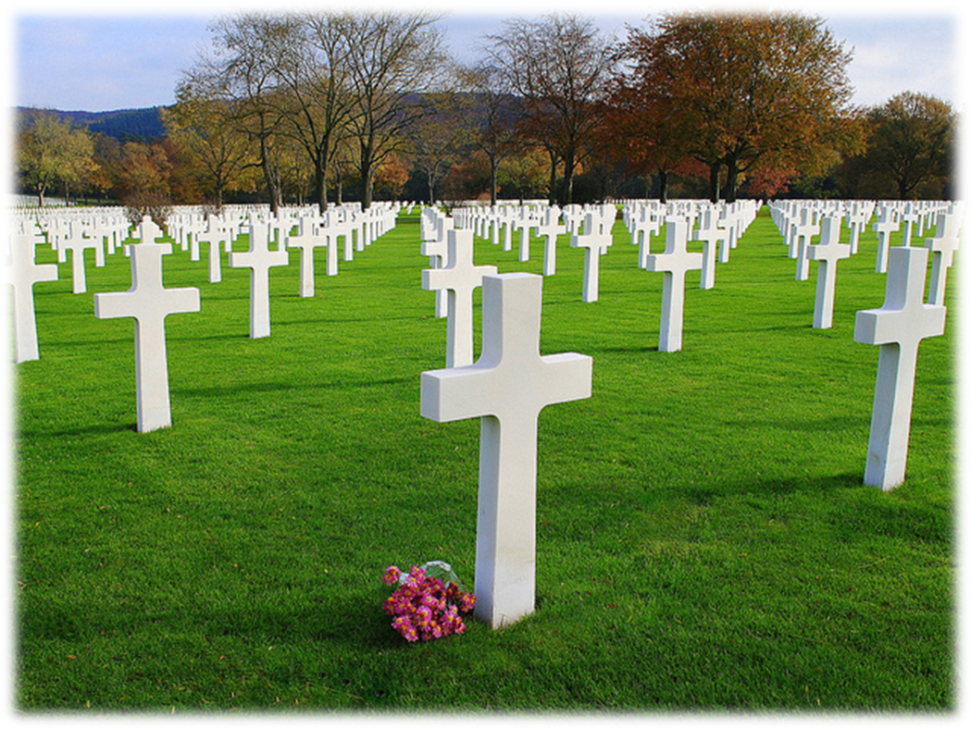

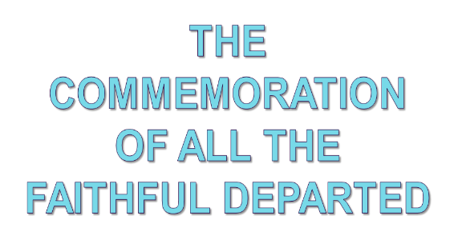

1st Reading: Isaiah 25:6-9
A vision of hope for the future, when God will restore his people to happiness
On this mountain the Lord of hosts will make for all peoples a feast of rich food, a feast of well-aged wines, of rich food filled with marrow, of well-aged wines strained clear. And he will destroy on this mountain the shroud that is cast over all peoples, the sheet that is spread over all nations; he will swallow up death forever.
Then the Lord God will wipe away the tears from all faces, and the disgrace of his people he will take away from all the earth, for the Lord has spoken.
It will be said on that day, ‘Lo, this is our God; we have waited for him, so that he might save us. This is the Lord for whom we have waited; let us be glad and rejoice in his salvation.’
Responsorial: Psalm 26: 1, 4, 13-14
Response: The Lord is my light and my salvation
The Lord is my light and my help;
whom shall I fear?
The Lord is the stronghold of my life;
before whom shall I shrink? Resp:
There is one thing I ask of the Lord,
for this I long,
to live in the house of the Lord,
all the days of my life,
to savour the sweetness of the Lord,
to behold his temple. Resp:
O Lord, hear my voice when I call;
have mercy and answer.
It is your face, O Lord, that I seek;
hide not your face. Resp:
I am sure I shall see the Lord’s goodness
in the land of the living.
Hope in him, hold firm and take heart.
Hope in the Lord! Resp:

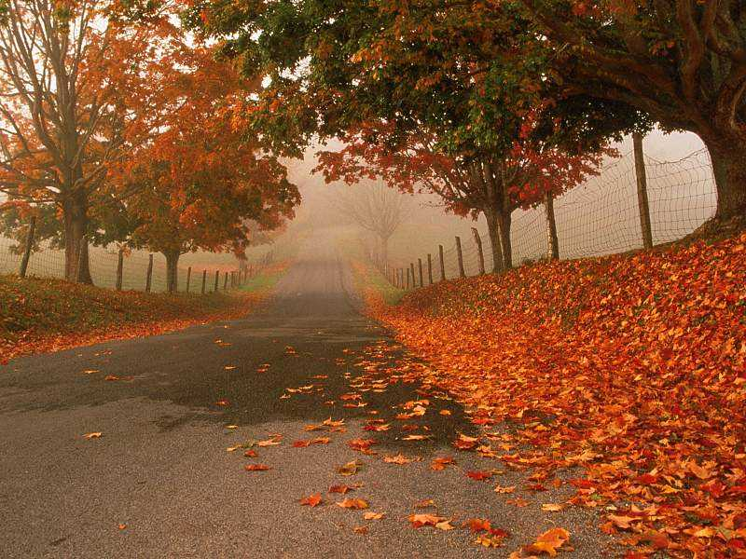

Gospel: Matthew 11:25-30

Jesus tells us of the Father’s gracious presence

Jesus said, “I thank you, Father, Lord of heaven and earth, because you have hidden these things from the wise and the intelligent and have revealed them to infants; yes, Father, for such was your gracious will. All things have been handed over to me by my Father; and no one knows the Son except the Father, and no one knows the Father except the Son and anyone to whom the Son chooses to reveal him.
“Come to me, all you that are weary and are carrying heavy burdens, and I will give you rest. Take my yoke upon you, and learn from me; for I am gentle and humble in heart, and you will find rest for your souls. For my yoke is easy, and my burden is light.”
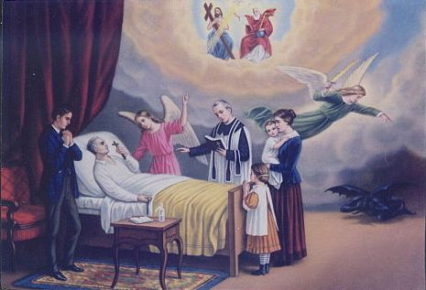

Reflections:
Live a Life That Matters
Ready or not, someday it will all come to an end
There will be no more sunrises, no minutes, hours or days.
All the things you collected, whether treasured or forgotten, will pass to someone else.
Your wealth, fame and temporal power will shrivel to irrelevance.
It will not matter what you owned or what you were owed.
Your grudges, resentments, frustrations, and jealousies will finally disappear.
So, too, your hopes, ambitions, plans, and to-do lists will expire.
The wins and losses that once seemed so important will fade away.
It won't matter where you came from,
or on what side of the tracks you lived, at the end.
It won't matter whether you were beautiful or brilliant.
Even your gender and skin colour will be irrelevant.
So what will matter? How will the value of your days be measured?
What will matter is not what you bought, but what you built;
not what you got, but what you gave.
What will matter is not your success, but your significance.
What will matter is not what you learned, but what you taught.
What will matter is every act of integrity, compassion, or sacrifice that enriched, empowered or encouraged others to emulate your example.
What will matter is not your competence, but your character.
What will matter is not how many people you knew, but how many will feel a lasting loss when you're gone.
What will matter is not your memories, but the memories that live in those who loved you.
What will matter is how long you will be remembered, by whom and for what.
Living a life that matters doesn't happen by accident.
It's not a matter of circumstance but of choice.
Remember: One day you will pass away from this world
What I gave when I was alive is what I receive when I pass away... The Kingdom of God is the aim of my earthly life.
****************
That “One Day” is a sober reminder that as living, material organisms, our bodies will one day give out. Somewhere, sometime, sooner or later, we will come face to face with our personal death. As the Old Testament puts it, we shall go to join our ancestors.
And then what? Is it all over for one’s personal existence? Is it to be extinction, silence, darkness? Will there be no more love, no more joy, no more relationships?
Jesus points us to a more hopeful future. He passed through the doors of suffering and a cruel death to come back and say there is light and love and joy, a life beyond what we can imagine. He offers hope for those who find it possible to trust in him. What does this feast ask of us? Be grateful for what you have. See what love the Father has bestowed on us!
Why do we actually pray for the people who have gone before us? It’s a human tradition, and for Christians it’s based on the hope taught by Jesus himself. He once said: “All that the Father gives me will come to me; and whoever comes to me I will not cast out.”
Today our Church is praying for all the deceased, for all the people we knew, but also for all the millions of others who have passed on from this life.
We remember many whom we have known and loved — family members and good friends and the wider circle of everyone we have met in life, who have passed on. Indeed, the whole month of November is specially devoted to remembering our dead. This is a prayerful remembering, keeping their memory in our hearts, while we seek God’s presence. Praying for our loved ones expresses our ongoing communion with them.
We commit all who are gone ahead of us to God, who also accompanies us on our journey of life. Our communion in the church keeps us in fellowship with all who have died. Praying for them, we ask that they may have life, as the Lord brought the widow’s son to life. We are also grateful to them, thanking God for the gift of their lives and all the ways we were blessed through them.
Today, we entrust them all to God. As “God’s love has been poured into our hearts by the Holy Spirit which has been given to us,” we pray that they now experience God’s love and light to the full. Amen.

Choose the Lord Jesus:
Because: * He is the Light of the world;
* He is the Way, the Truth and the Life.

